Hackerearth question
Roy and Profile Picture | Basics of Input/Output & Basic Programming Practice Problems
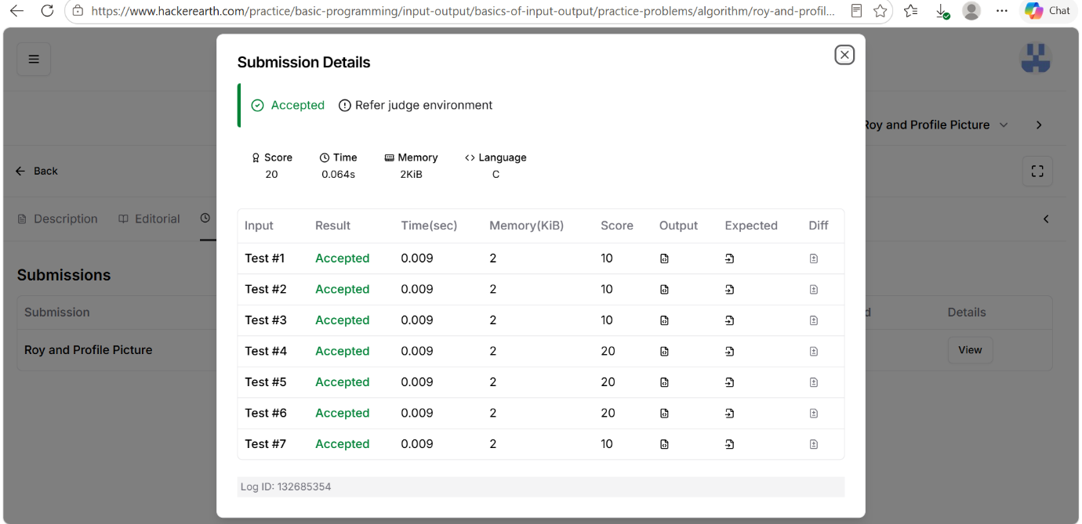
Code
#include <stdio.h>

int main() {
int L, N, W, H;

scanf("%d", &L);
scanf("%d", &N);

while (N--) {
scanf("%d %d", &W, &H);

if (W < L || H < L)
printf("UPLOAD ANOTHER\n");

else if (W == H)
printf("ACCEPTED\n");

else
printf("CROP IT\n");
}

return 0;
}

